DIsco 1.16
User Manual

Developed by Luke P Frash
Los Alamos National Laboratory


Outline
1. Quick Start 3
1.1 Installation 3
1.2 Startup 3
1.3 Exiting DIsco 3
1.4 Main window overview 3
1.4.1 Data output (saving) 4
1.4.2 Basic pump controls by index 5
1.4.3 Valve (digital output) controls by index 7
1.4.4 Monitoring panel 8
2. Advanced Controls 10
2.1 DIsco settings 10
2.1.1 Data call rate 10
2.1.2 Logging and data recovery 10
2.2 Manual commands 10
2.3 Variables and math 12
2.4 External data referencing 13
2.5 Pump routines 13
3. Manually editing the settings file 15
4. Basic Troubleshooting 16
5. Hardware Recommendations 17

Quick Start
DIsco is a dynamic Teledyne Isco D-series syringe pump control interface developed for Windows using LabVIEW. The base functions of DIsco enable RS-232 (serial) communications for remotely controlling and monitoring any number of Teledyne Isco pumps (currently verified for up to 6 pumps). Data acquired from the pumps can be plotted near real-time to aid the user with process monitoring and also saved in a comma delimited ASCII text file. The more advanced features of DIsco include custom pump routine development, external data fetching, and manual serial commands.

Installation
DIsco includes an install file called "Setup.exe" which contains all the required LabVIEW divers necessary to run the program on a Windows operating system. If LabVIEW is prior installed, it is recommended that a custom install directory is selected to avert potential compatibility issues. Installation can take some time to complete. The read/write security settings of the default install directory can interfere with full featured execution of DIsco. After installing the program, it is recommended that the DIsco install folder be set to allow both read and write access (requires administrative access). Contact your local IT to ensure that this setting is compatible with your local security requirements.

Startup
Initial execution of DIsco gives includes a routine to automatically detect and begin communication with any Teledyne Isco D-series pumps that are attached to your computer. This routine searches for active RS-232 serial ports on your computer then polls each port searching for compatible pumps. The current version of DIsco is default configured for a baud rate of 9600 which typically provides for stable communication with the Teledyne Isco Legacy Controllers and is therefore recommended. Consult the manufacturer's manual for the procedure to change the baud rate if needed. Communication with the pumps is established automatically if any pumps are detected. The serial port communication information is saved in a text file named "Settings.csv" that is created in the DIsco install directory and can be manually edited if needed. Subsequent startups of DIsco do not require that you automatically detect pumps but this feature is available in the event that any hardware changes have occurred. Note that baud rates other than 9200 can be used if desired, these settings are manually accessed in "Settings.csv".

Exiting DIsco
At the top-right of the main window is a red "Exit" button. This button saves the DIsco program settings for future restarts and is therefore the preferred method for closing DIsco. The standard Windows close button is also included at the top right if the user does not want to save the current settings.

Main window overview
The front panel of the program is shown below (Figure 1). The main window is arranged into four general panels including the output panel, the pump control panel, the monitoring panel, and the advanced control panel. This arrangement is fixed in this version of DIsco and therefore cannot be adjusted. Tooltips are provided in DIsco to assist user identification of the various available controls and their functions.
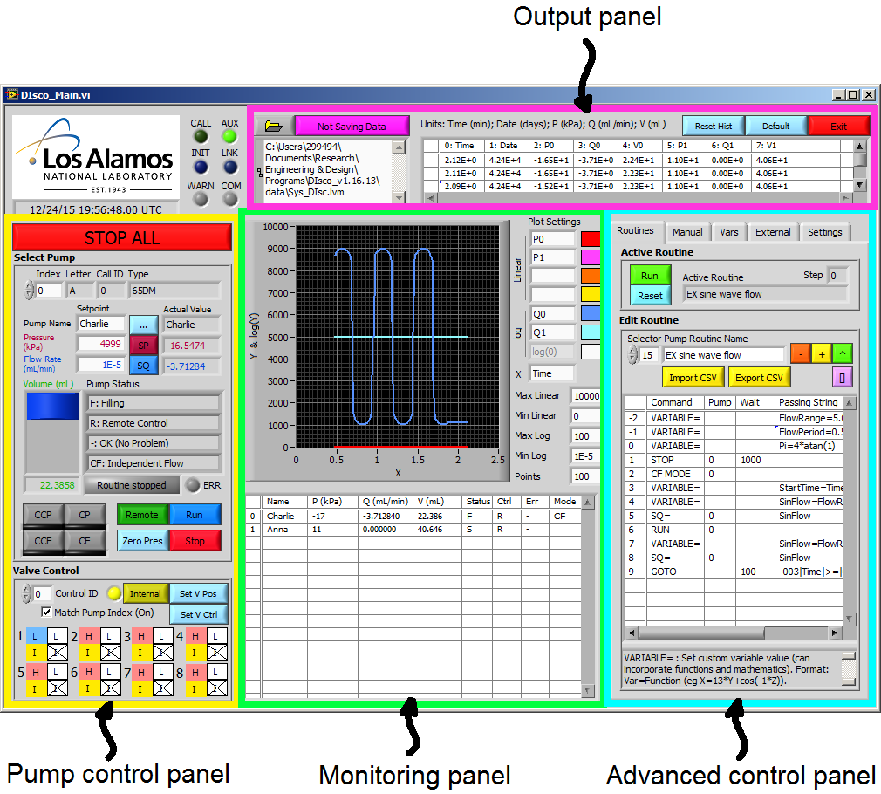
Figure 1. Main window of DIsco operating two pumps via one pump controller. This window is organized into four main panels being (top) the output panel, (left) the pump control panel, (center) the monitoring panel, and (right) the advanced control panel. The top left provides DIsco status indicators and a UTM timestamp, intended for debugging and synchronization purposes.

Data output (saving)
Data saving is accessed in the output panel with the default setting being "Not Saving Data". To activate data saving it is recommended that you first specify a directory and filename then click the "Not Saving Data" button. The button then changes to "Saving Data" and is green in color, indicating that data is now being saved. All data saving is configured as appending to reduce the risk of overwriting any existing data and to prevent data loss in the event of hardware/software crashes. The save function is configured to create comma delimited text files with up to 10,000 rows (i.e. line returns). For longer data sets, additional files are created with incrementally increasing names.
Example data output from DIsco with two pumps and one controller is provided below:
,42173.98,2252.40,0.02,13.16,3344.12,0.00,58.34,R,R,-,S,R,-,H,H,H,H,H,H,H,H
,42173.98,2251.02,0.03,13.16,3344.12,0.00,58.34,R,R,-,S,R,-,H,H,H,H,H,H,H,H
,42173.98,2251.02,0.02,13.16,3345.50,0.00,58.34,R,R,-,S,R,-,H,H,H,H,H,H,H,H
,42173.98,2252.40,0.01,13.16,3344.12,0.00,58.34,R,R,-,S,R,-,H,H,H,H,H,H,H,H
...

The sequence of this data is as follows:
(0; leftmost column) empty time column
(1) date stamp in 0/0/1900 00:00 UTM format
(2) pump index 0 pressure in kPa
(3) pump index 0 flow rate in mL/min
(4) pump index 0 volume in mL
(5 to 7) pump index 1 pressure, flow rate, and volume
(8) pump index 0 status
(9) pump index 0 control status
(10) pump index 0 error status
(11 to 13) pump index 1 status
(14 to 21) valve status controller index 0
Expanding the system for more pumps adds the additional pump data in order following the respective index numbers. Adding additional controllers adds additional sets of 8 valve status indicators.

Basic pump controls by index
Basic pump and valve controls are accessed by the pump control panel (Figure 1: left; Figure 2). Perhaps most important function is the large "Stop All" button which can be used to quickly stop all pumps that DIsco is communicating with. The target pump being controlled is specified by pump index (top-left of panel). Switching between pump indices refreshes the corresponding input boxes and updates the displayed status values to match the respective selected pump. A pump naming feature is included to aid user identification of the different pumps in the system. In this example (Figure 2) the selected pump has been named "Charlie".
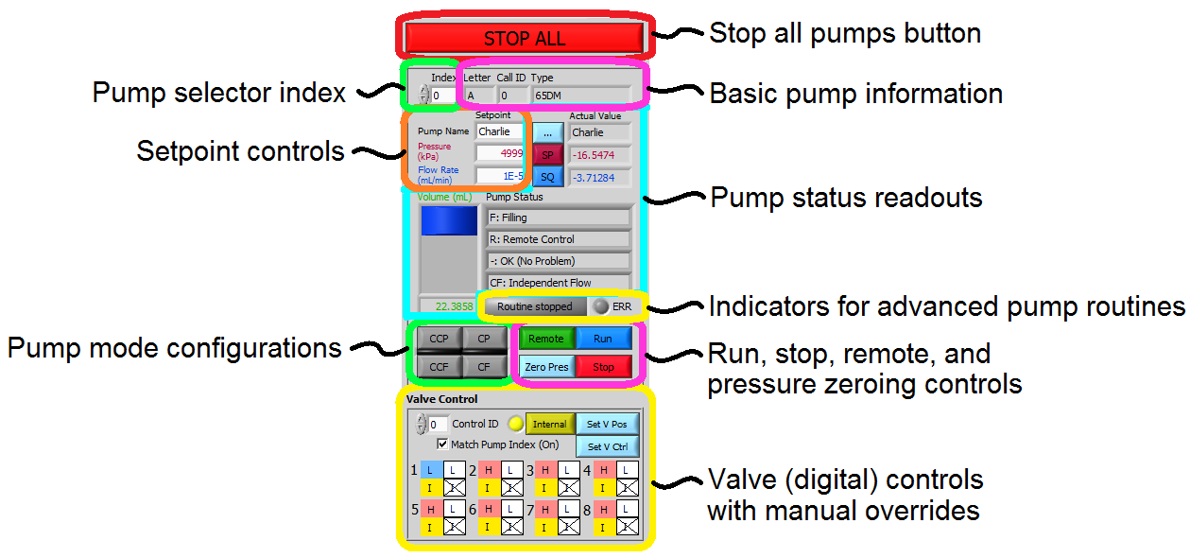
Figure 2. Basic pump controls accessed in the pump control panel. Note that pumps and valves have index selectors to aid control of multi-pump systems (more than 3 pumps; more than 1 controller). The valve index selector can be tied to the pump index selector using the "Match Pump Index" checkbox to simplify control as suitable for some systems.
The basic pump information includes the pump type (e.g. "65DM"), pump letter (e.g. "A"), and call ID (e.g. "0"). The pump type aids identification in multi-pump systems and verifies good communication. Refer to the troubleshooting section of this manual if the pump type displays as "Unknown". The pump letter refers to the position of the pump connection on the back of the pump controller. Note that all controllers require a pump "A" and built in continuous constant flow/pressure capabilities (referred to as "CCF" and "CCP" in DIsco) require that both pumps "A" and "B" have matching type. The Call ID is a DIsco index reference uniquely matching pumps with their respective controllers. This number is used when accessing controls such valves (i.e. digital voltage outputs).
Setpoint controls include target pressure and flow rate setpoints. The associated values are changed via the corresponding buttons to the right of each input box. Positive flow rate values are used to specify outflow and negative flow rate values are used to specify refill rates. Take care when changing the setpoints while the respective pump is running ("R" or "F") in constant flow mode ("CF" or "CCF") because switching from positive to negative values will reverse the pump flow (and vice-versa). This behavior differs from the standard pump function as intended per the manufacturer but simplifies controls. Soft limits are included in DIsco to override invalid setpoint values. These soft limits are set according to both the user specified limits and the physical limits per pump type. Note that it is possible to command flow rate and pressure setpoints outside the physical limits of a given pump via serial communication. These soft limits are intended to prevent such invalid commands from being passed to the pumps, thus helping prevent accidental failures.
Pump status readouts include the most recently acquired (serial) pressure, flow rate, and volume information as well as the operational state, control status, and error state of the pump. The operational state, control status, and error state are printed as single character values in the output data (save file) but are interpreted in DIsco as plain text for the ease of the user. In this example, "Charlie" is currently filling ("F") at approximately 3.7 mL/min and it being remotely controlled ("R") with no errors ("-"). The control mode is independent constant flow ("CF"), so control of pump "A" is not automatically tied to pump "B". Note that the manufacturer's current serial communication protocol cannot identify the current control mode of the pumps so this is unknown by default when DIsco is started up. While DIsco is running, it is assumed that the user is changing the control mode solely using DIsco (not manually via the pump controller).
Advanced functionalities of DIsco include the ability to program pump routines. If a routine is running, this is indicated in the pump control panel as gentle reminder for the user.
The pump control mode can be set using the pump mode configuration buttons. The available modes include:
- CF: Constant flow rate control mode (direct)
- CP: Constant pressure control mode (via PID)
- CCF: Continuous constant flow rate control mode (direct using pumps "A" and "B" along with remote controlled valves)
- CCP: Continuous constant pressure control mode (via PID using pumps "A" and "B" along with remote controlled valves)
The pump can be enabled to run using the "Run" button. The pump can be stopped (individually) using the "Stop" button. The pressure reading can be digitally zeroed using the "Zero Pres" button. The control state of the pump controller can be toggled using the "Remote"/"Local" button, switching state when clicked.

Valve (digital output) controls by index
The DIsco valve (digital output) controls include two functionalities, position and control state. Valve positions can be set manually at any time using the "Set V Pos" button. This button sets all valves on the controller to match the positions specified by the corresponding (upper) check boxes. When using the Teledyne Isco valve hardware, a digital high output ("H") closes a valve and a digital low output ("L") opens a valve. These positions can differ for custom built valve or digital control systems. By default, the Teledyne Isco pump controller will switch the valve positions automatically when the pump is running ("R"), filling ("F"), or stopped ("S"). This automated control state is referred to as internal control ("I"). In some cases, it is beneficial to disable this automatic control and instead control the valves manually using DIsco, this option is referred to as remote control ("R"). The control state can be specified for each valve separately using the "Set V Ctrl" button or toggled for all values using the adjacent "Internal"/"Remote" button. Refer to the Teledyne Isco pump manual for more information on this topic. A check box labeled "Match Pump Index" is provided if the user desires the controller index (for valve control) to be linked to the selected pump index.

Monitoring panel
The monitoring panel includes an XY-plot and a pump status table. The plot includes linear and semi-logarithmic scaling capabilities that are well suited for pressure and flow rate monitoring, respectively. The status table concisely gives the most recently acquired data and status for all pumps in communication with DIsco. In this case, two pumps are connected named "Charlie" and "Anna" with index references of 0 and 1 respectively.
Up to four linear series and two logarithmic series can be plotted at a single time. The relevant system variables actively used for plotting are stored locally in a history array that is shown in the output panel (Figure 1). The plot display can be adjusted using the plot settings options which includes selection options for the plotted variables (by color). The abscissa (x-axis) can be user configured to plot against any variable with the default being "Time" with units of minutes. The default system variables that are commonly useful for plotting are given in Table 1. A full list of the available variables for plotting is viewable in the advanced control panel "Vars" tab. Note that the semi-log plot permits plotting the logarithm of positive, zero, and negative values with respect to user-set minimum and maximum absolute values. Positive logarithmic values are plotted above the indicated reference line (white), negative values are plotted below, and zero (minimum) values are plotted on the reference line. This differs from conventional logarithm plots which do not allow viewing log(0). The formula used for the logarithmic series varies with plot-scale and is displayed in the advanced control panel "Settings" tab.
Table 1. Common DIsco variables used for plotting.
Variable Prototype | Parameter | Example (pump index 0)
V# | Pump volume (mL) | V0
P# | Pump pressure (kPa) | P0
Q# | Pump flow rate (mL/min) | Q0
Time | Time (min) | Time
Date | Date (days); 1900/0/0 UTM | Date

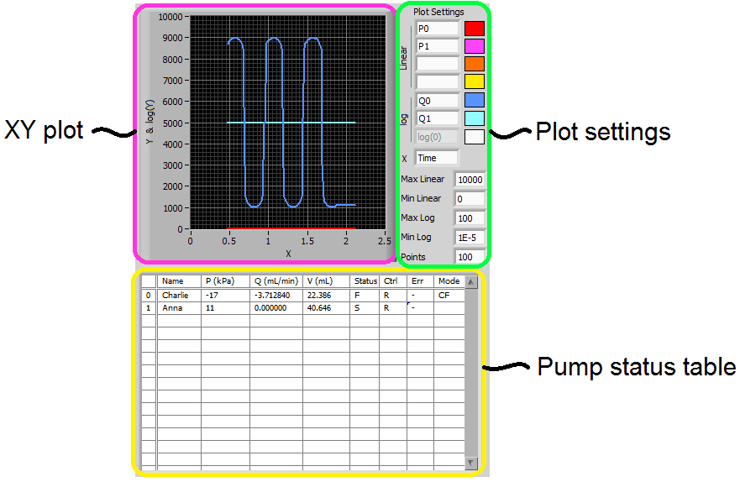
Figure 3. Pump monitoring panel for customizable data visualization and full system status monitoring.

Advanced Controls
Advanced syringe pump users may desire custom pump control methods specific to a given application. For example, the pressure in pump "B" for a given procedure may need to be 500 kPa less than the pressure in pump "A" at all times. Or perhaps the combined flow rate of pumps "A" and "B" must be managed to achieve a given displacement rate as measured by an auxiliary LVDT. DIsco was designed with such capabilities in mind and some example pump routines are included. Additionally, some basic DIsco customization features are available through the settings options.

DIsco settings
The advanced control panel includes settings for startup and exit, data calling, and information regarding the status of custom pump routines that can be of use for debugging.

Data call rate
The data calling rate is the frequency with which DIsco requests the status of the pumps. A readout below this setting gives the most recent elapsed data call time (in milliseconds) as a reference for determining a suitable maximum data call rate. A suitable maximum data call rate can be calculated as:
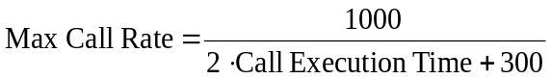 (1)
This call rate can be accelerated in a multi-pump system by consolidating pumps onto as fewer controllers as possible. Each controller typically consumes 200 to 350 ms when poled for status, regardless to the number of pumps attached.

Logging and data recovery
DIsco includes a secondary data logging system intended for debugging. This system logs all commands passed to the pump controller along with the replies from the controller. The format of this file is comma delimited but otherwise raw with respect to parsing and interpretation of the replies. Interpretation of this file requires knowledge of the DASNET command protocol that the pumps use to communicate as well as familiarity with the advanced functions unique to DIsco. In the event of data loss from the primary file saving system, there is a possibility that the data can be recovered from the DIscoLog files. An option exists to disable this secondary log to speed up DIsco and prevent excess data accumulation.

Manual commands
Manual pump commands in DIsco enable access to most DASNET serial commands, including the lesser used and more advanced pump controls. For convenience, the commands can be typed in directly or looked up from an indexed list complete with descriptions of the command. When relevant, manual commands are executed with reference to a pump index that is also located in the manual command tab. Some manual commands (e.g. "SQ=") require passing values that can be entered in the provided “Append” text box. Table 2 summarizes the available manual commands in DIsco. Note that limit settings (e.g. "UP=") are restricted to maximum or minimum values per the pump type. Caution: if the pump type is “Unknown” the pressure, flow rate, and volume maximum limit settings are assumed at 13790 kPa, 25 mL/min, and 1015 mL respectively.
Table 2. Manual and custom routine commands available in DIsco.
Command | Passing Value | Description
CLEAR | - | Stops all pumps on the pump's controller and resets the controller settings
CLEAR ALL | - | Stops all pumps and resets settings on all controllers
STOP | - | Stops the specified pump
STOP ALL | - | Stops all pumps
RUN | - | Activates the specified pump in its respective mode
REFILL | - | Refills the specified pump at maximum rate
CF MODE | - | Enables constant flow rate mode on the given pump
CP MODE | - | Enables constant pressure mode on the given pump
CCF MODE | - | Enables continuous constant flow rate mode on a pump "A" and "B" pair; requires that the command references the pump "A" index
CCP MODE | - | Enables continuous constant pressure mode on a pump "A" and "B" pair; requires that the command references the pump "A" index
SQ | - | Requests the current flow rate setpoint
SQ= | Double | Sets the flow rate setpoint (mL/min)
SP | - | Requests the current pressure setpoint
SP= | Double | Sets the pressure setpoint (kPa)
ALOG | - | Return status of an analog voltage input for specified pump's controller. Format: Integer 1-5.
DIGITAL | - | Requests the valve position status (high or low)
DIGITAL= | 8 character string of H's and L's | Sets the (valve) positions for all 8 digital outputs from a controller
SINGLE DIGITAL= | 2 character string of integer and H or L | Sets the (valve) position of a single digital output from a controller
DIGITAL CTRL | - | Requests the valve control status (internal or remote)
DIGITAL CTRL= | 8 character string of R's and I's | Sets the (valve) control status for all 8 digital outputs from a controller
GET ALL | - | Requests the status of the pumps on the specified pump's controller
IDENTIFY | - | Requests the model information for all pumps connected to a controller.
LIMITS | - | Requests the pressure and flow rate limits set on a specified pump
LQ= | Double | Sets the lower flow rate limit on a specified pump
UQ= | Double | Sets the upper flow rate limit on a specified pump
LP= | Double | Sets the lower pressure limit on a specified pump
UP= | Double | Sets the upper pressure limit on a specified pump
PID= | - | Enables or disabled PID pressure control. 0 or 2 for disable, 1 (default) for enable.
MQCP= | Double | Sets the maximum flow rate for constant pressure control mode
LOCAL | - | Disables remote (serial) control of a pump controller
LOCAL ALL | - | Disables remote (serial) control of all pump controllers
REMOTE | - | Enables remote (serial) control of a pump controller
REMOTE ALL | - | Enables remote (serial) control of all pump controllers
ZERO | - | Zeroes the pump's pressure reading
SUB | Routine's name | Enters into a custom pump subroutine (used in pump routine programming)
GOTO | See in-program description | A conditional goto command used for if statements and loops
VARIABLE= | Math expression | Sets a custom variable value using a mathematical expression
ALERT | Double | Emits and audible two-tone alert
UNITS= | See pump manual | Warning: Do not change the units from mL, min, and kPa

Variables and math
The "Vars" tab can be used to view and edit variables inside DIsco. All variables are stored in DIsco as a name string and an accompanying double value. A collection of variables (e.g. "Time") are standard and automatically updated through data calls and other commands. New variables can be created using programmatic mathematical expressions. For example, "Var01=13.17" will create a variable named "Var01" with a value of 13.17. As a subsequent example, "Var02=Var01-sin(Time/4)" will create a variable named "Var02" and assign it a value as calculated from the right-hand-side (RHS) expression "Var01-sin(Time/4)". In this example, "Time" is a standard variable that is updated with every data call, "sin(...)" is a built in function, and "Var01" is taken as the value 13.17 per the previous example. If Var02 already exists, it's value overwritten with the evaluated RHS expression. Note that overwriting standard variables will not change their respective control values and is therefore not recommended.
The current functions (not case sensitive) available in DIsco for mathematical expressions are the following:
- abs()
- sin()
- cos()
- tan()
- asin()
- acos()
- atan()
- sign()
- int()
- ln()
- log(): base 10
- exp()
- else: return value in parentheses with no function

Operators and order of operations are interpreted in the following sequence:
- (): parenthesis
- **: power
- ^: power
- *: multiply
- /: divide
- -: negate
- -: subtract
- +: add

Numbers can be expressed as integers or as doubles with the following notation:
- 13: positive integer
- 13.17: positive double
- 13.1756E78: large double scientific
- 8.7654E-32: small double scientific
- -13: negative integer
- -13.17: negative double
- -13.1756E78: negative large double scientific
- -8.7654E-32: negative small double scientific

The current interpreter implemented in DIsco does not have any functionality to alert the user of invalid expressions and will consider all expressions as valid. Due to this, it is encouraged that you verify the results from an expression using the manual "Vars" tab against alternative software.
Variables can be used as the passing value for any manual commands that pass a double value. For example, the manual command "SQ=" can be passed "Var01", thereby setting the current flow rate setpoint to 13.17 per this example. The utility of this functionality is directly relevant to custom pump routine programming.
Note that any variable can be plotted in the monitoring panel simply by inserting it's name into the plot settings. Once inserted, the value of the variable will be recorded with every data call in the data history array that can be viewed in the output panel.

External data referencing
External data referencing is a feature of DIsco by which data outputs from other programs can be read in and stored as a special type of custom variable. This feature is accessed in the "External" tab. This feature expects appending comma delimited text files to operate properly. Imported data is parsed into a 2D array where columns are assumed to be channels and rows are assumed to be sequential entries (i.e. time series). “Add New Column…” stores the value from the last row of a specified column (external text file) in DIsco as a special variable. This value is subsequently updated (queried) at the Data Call Rate. Hence, measurements from data loggers external to DIsco can be integrated with DIsco functions. Errors can occur between DIsco and the external program if both attempt to access the same file at the same time. In this event, DIsco will temporarily skip the external data query and resume without interruption. However, DIsco accessing the file can sometimes cause the external program to crash if the external program doesn't have file access error handling.

Pump routines
The most advanced capabilities of DIsco are developed using pump routines (Figure 4). Pump routines are handled by a comma-delimited file import-export. By default, pump routines are expected to be stored in a folder named "programs" that is located in the DIsco home directory. All *.csv files located in this directory are automatically loaded into DIsco on startup and are accessible for execution as well as editing. Routines can be written in DIsco or using external programs and then imported using the "Import CSV" button. This capability is makes routine sharing between users simple and easy.

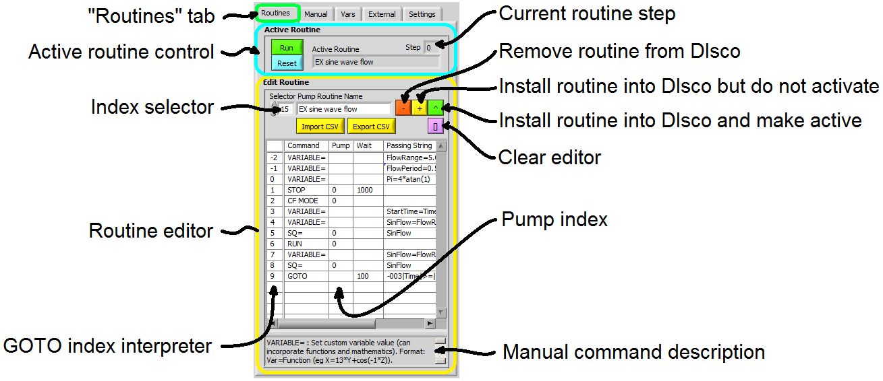
Figure 4. Pump routine editor and controls.
Custom pump routines are written in a four column format. The first (leftmost) column specifies a manual command (c.f. Table 2). The second column specifies the index of the pump that is to be commanded, in this case pump index 0 (i.e. "Charlie"). The third column specifies a wait timer with the default value being 0 milliseconds if not otherwise specified. The fourth column is used for passing values. Any additional columns are not interpreted and can therefore be used for comments. An example pump routine for sine-wave pump flow (c.f. Figure 3) is shown below:
VARIABLE=,,,FlowRange=5.0,
VARIABLE=,,,FlowPeriod=0.5,
VARIABLE=,,,Pi=4*atan(1),
STOP,0,1000,,
CF MODE,0,,,
VARIABLE=,,,StartTime=Time,
VARIABLE=,,,SinFlow=FlowRange*(sin(2*Pi*(StartTime-Time)/FlowPeriod)),
SQ=,0,,SinFlow,
RUN,0,,,
VARIABLE=,,,SinFlow=FlowRange*(sin(2*Pi*(StartTime-Time)/FlowPeriod)),
SQ=,0,,SinFlow,
GOTO,,100,-003|Time|>=|0,

After selecting a routine, it can be installed into DIsco and executed. This method of implementation enables pump routine editing without interruption of data acquisition, a feature that can be beneficial for long term studies. Note that manual manipulation of variables and pump settings outside the pump routine can be used to further enhance the utility of a given routine. Also, the wait timer or use of the Date variable can be used for programmatically scheduled changes in the pump states.

Manually editing the settings file
In some situations, it may be necessary to manually set the pump connection information by editing the "settings.csv" file. An example "settings.csv" file as viewed with Notepad is shown below. The settings are delimited with commas, semi-colons, and line returns. The first line specifies the serial communication settings with a single pump entry highlighted below. Each entry (separated by semi-colons) contains the following information in order (separated by commas):
- Pump name (user specifiable string)
- Pump position on controller ("A", "B", "C", or "D")
- Pump serial port number ("1" = COM1)
- Controller baud rate (9600 recommended and default)
- Controller identification number (1-6; set by the controller's serial option menu)
- Pump type (e.g., "65DM")
- Call index number (automatically optimized at startup)
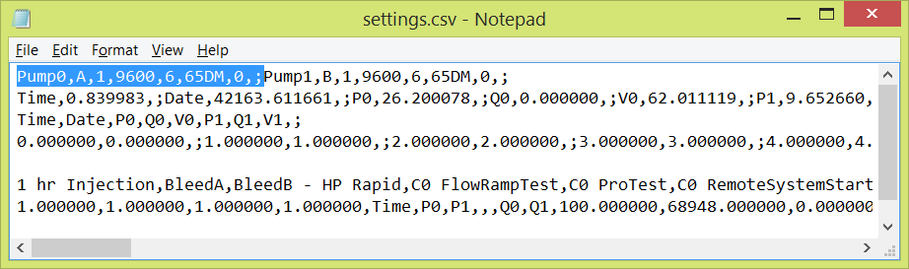
Manually setting the pump serial connections requires properly specifying (2) the pump position, (3) serial port, (4) baud rate, (5) and controller identification number for each desired connection. Other settings are automatically updated or can be manually updated while the program is running. Note that any edits to "settings.csv" should be completed prior to startup.

Basic Troubleshooting
Problem | Cause | Fix
Pump controller is beeping and DIsco is not responding | The pump controller is in a sub-menu | Place the pump controller on a home screen such as the select pump menu; restart DIsco
AUX never illuminated /  CALL always illuminated / data acquiring but no other commands function | Acquisition rate is too fast | Reduce the data call rate in "Settings" tab
INIT light not turning off | Initial startup is occurring but taking some time | Patience
WARN light is illuminated | A serial communication failure occurred during startup | Restart DIsco; check serial cabling; check hardware drivers
COM light is illuminated | Intermittent serial communications failures are occurring | Check serial cabling; check hardware drivers
ERR light is illuminated | Intermittent serial communications failures are occurring | The custom pump routine may have had an error; routine reset recommended
Valve positions change without command/ when pumps are stopped/ when activating run | Valve internal control is enabled | Toggle valves to remote control and set positions manually
Pumps are refilling too slowly | Flow rate set point is too low | Set the flow rate to a greater negative value  Alternate: send the manual command "REFILL"
Pumps in CP/CCP mode are not flowing quickly or at all but are running | Maximum flow rate limit in constant pressure mode is set too low | Send manual command "MQCP=" with an appropriate flow rate limit  Warning: Pump controllers do not reliably interpret this limit, in some cases a specified value of 10.0 mL/min may cause a 1.0 mL/min or lesser actual limit
Plot is plotting nothing | Plot settings are incorrect | Adjust max and min limits; check plot series names (case sensitive); increase "Points"

Hardware Recommendations
- Windows OS
- Multi-core processor
- 1024x786 minimum screen resolution
- Teledyne Isco D-Series syringe pump(s) with Legacy controller(s)
- RS-232 computer ports and cabling

